1-

The Cartesian coordinates of a point in the xy plane are ***(x, y) = (23.50, 22.50)*** m. Find the polar coordinates of this point.



2-

The polar coordinates of a point are ***r = 5.50 m*** and ***θ = 240°***. What are the Cartesian coordinates of this point?



3-

If and , Find ? (Ans: 32)



4-

Starting from one point, a person walks **25 km** in a direction **30° south of west** and then walks **30 km** toward **the north** to a second point.



1. What distance separates the two points? (Ans: 28 km)
2. What is the direction from the first point to the second point? (Ans: 39o)

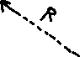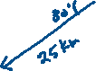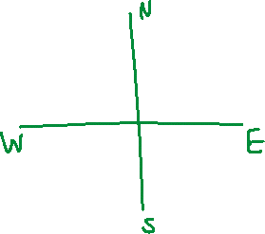

5-

Vectors and are shown. Find ? (Ans: 46)

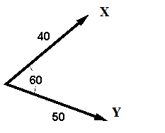

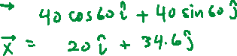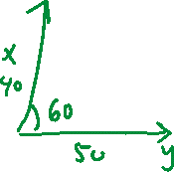

6-



7-

Consider the following two vectors and . Calculate:

1. |
2. The direction of

8-

Three displacement vectors of a croquet ball are shown in Figure, where units, units, and units. Find:

(a) the resultant in unit-vector notation. (Ans: )

(b) the magnitude and direction of the resultant displacement. (Ans: [56.4, 28.7o])



9-



A girl delivering newspapers covers her route by traveling 3.00 blocks west, 4.00 blocks north, and then 6.00 blocks east. What is her resultant displacement?

*Ans: R=5 blocks, θ=53o.*

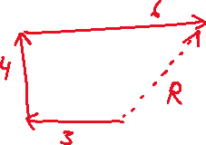

10-

Vector has *x* and *y* components of -8.70 cm and 15.0 cm, respectively; vector has *x* and *y* components of 13.2 cm and -6.60 cm, respectively. If , what are the components of ?

*Ans: = 7.30ˆi − 7.20ˆj or Cx = 7.30 cm; Cy = −7.20 cm.*

